解题报告：Clans on the Three Gorges

题目来源：http://acm.pku.edu.cn No.1682
解法或类型： 动态规划
作者：杭杰
Clans on the Three Gorges
Time Limit:1S Memory Limit:1000K
Total Submit:34 Accepted:10
Description
On the banks of the Three Gorges of the Yangtze River live some old clans. For historical reasons, clans on the same gorge hate each other, and conflicts often arise between them for lands and recourses. On the contrary they have a long and deep friendship with the clans on the other gorges. But it's difficult for them to travel to the other sides of the gorge because of the torrent flow of the Yangtze River.
One day they decide to build suspension bridges between the gorges. The gorges have three banks (figure 1), and each bank is rolling so clans have different altitude. Every clan will not share a same bridge with other clans on the same bank, so there must be at least one bridge for each clan. And for safety reason, bridges are not allowed to cross each other overhead, or if a bridge collapsed, it would fall on another one. Experts point out that if the altitudes of the two ends of a bridge are different, the bridge will be troublesome to build and cost more. It's estimated that the cost of a bridge is equal to the fall of the ends of the bridge. The clans are not rich, so they employ you to find a solution to minimize the cost to build the suspension bridges to satisfy their demand.
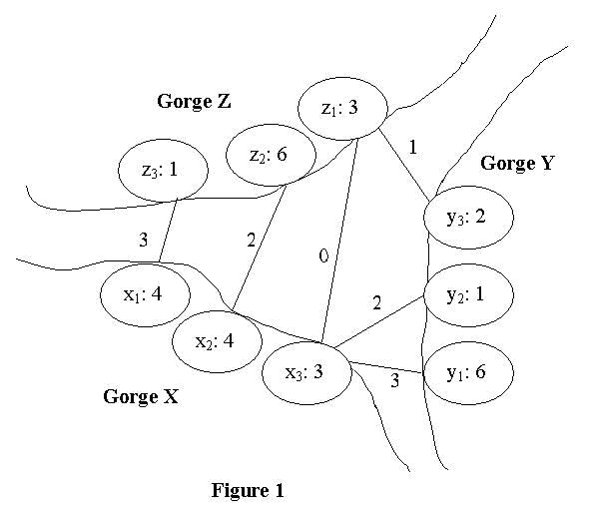
As show in figure 1, the three gorges are named X, Y and Z respectively. A clan is represented by a cycle, with its name and altitude in. Clans on gorge X are named x1, x2... xn in counter-clockwise order. Those on gorge Y and gorge Z are y1, y2... ym and z1, z2? zk in counter-clockwise order too. A bridge is represented by a line between two clans with its cost on it. No two lines can intersect and no clan has zero degree according to the description of this problem.
For example, figure 2 is invalid solution because the two bridges intersect. Figure 3 is also invalid for the reason that clan y1 doesn't has a bridge for its own. Figure 1 and Figure 4 both are valid solutions for there are no intersected bridges or isolated clan in these solutions. The cost of a solution is the sum of all the costs of the bridges in the solution. And the cost of a bridge is equal to the absolute value of the difference of the heights of the two ends. So figure 1 has cost 11 against 14 of figure 4. It's clear that figure 1 is a better solution. In fact, it's one of the best solutions. You are required to write a program to find the minimum cost.
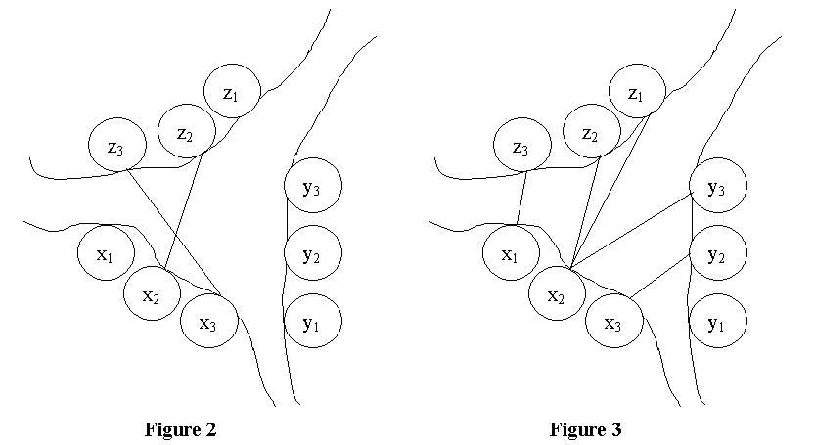

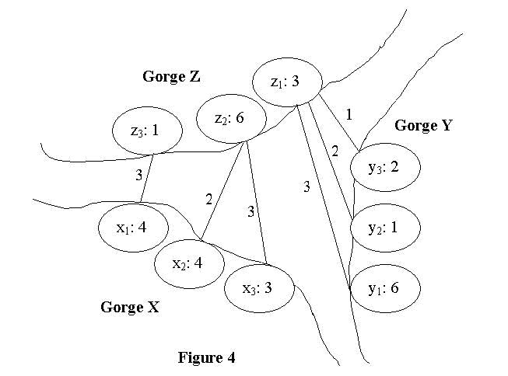
Input
The input consists of T test cases. The first line contains the number T (1 <= T <= 10). Then follow the T test cases. Each test case is started with a line contains three integers n, m and k (1 <= n, m, k <= 100), representing the number of clans on gorges X, gorge Y and gorge Z. The next three lines will contain the height of clans on the three gorges, the heights are positive integer less than 100. Test cases are separated by a blank line. The clans are named as described in the comment of figure 1. Their names also refer to their altitude. So the input of a case is of the form:
n m k
x1 x2 x3 ... xn
y1 y2 y3 ... ym
z1 z2 z3 ... zk
Output
The output contains T integers. Each line contains the minimum cost to the corresponding case of the input.
Sample Input
2
3 3 3
4 4 3
6 1 2
3 6 1

1 1 2
1
5
2 3
Sample Output
11
5
Source
epic

解题思路：

分情况讨论：

- 在x1、zｋ间架桥。
则x1、zk中至少有一个与其他点没有桥相连，否则去掉x1、zk之间的桥，仍满足要求，而总的花费不增加。又分三种情况：
- x1与至少一个其它点之间架桥。问题转化为在x1, x2, …, xn, y1, y2, …, yｍ, z1, z2, …, zk-1之间架桥，且每个点至少有一座桥，求最小花费。（子问题1）
边界情况：
k=1，问题转化为在x1, x2, …, xn, y1, y2, …, yｍ之间架桥，且每个点至少有一座桥，求最小花费。（子问题2）
- zｋ与至少一个其它点之间架桥。问题转化为在x2, x3, …, xn, y1, y2, …, ym, z1, z2, …, zk之间架桥，且每个点至少有一座桥，求最小花费。（子问题1）
边界情况：
n=1，问题转化为在y1, y2, …, ym, z1, z2, …, zk之间架桥，且每个点至少有一座桥，求最小花费。（子问题3）
- x1、zｋ与其他点都没有桥相连。问题转化为在x2, x3, …, xn, y1, y2, …, yｍ, z1, z2, …, zk-1之间架桥，且每个点至少有一座桥，求最小花费。（子问题1）
边界情况：
n>1，k=1，问题转化为在x2, x3, …, xn, y1, y2, …, yｍ之间架桥，且每个点至少有一座桥，求最小花费。（子问题2）
n=1，k>1，问题转化为在y1, y2, …, ym, z1, z2, …, zk-1之间架桥，且每个点至少有一座桥，求最小花费。（子问题3）

- 不在x1、zｋ间架桥。
则x1与zi（1<=i<k）之间无桥，否则由于每个点都有桥，任意两座桥不相交，zk只能与x1间架桥。同理zk与xi间无桥。设与x1有桥相连的y部分顶点中下标最大的为yi，与zk有桥相连的y部分顶点中下标最小的为yj。若i>j，则x1yi与yjzk相交。若i<j-1，则yj-1无桥。因此i=j或i=j-1。
问题转化为在x1, x2, …, xn, y1, y2, …, yi之间架桥，且每个点至少有一座桥，求最小花费。（子问题2) 和在yj, yj+1, yｍ, z1, z2, …, zk之间架桥，且每个点至少有一座桥，求最小花费。（子问题3)

三类子问题：
- 在xi, xi+1, …, xn, y1, y2, …, yｍ, z1, z2, …, zj之间架桥，且每个点至少有一座桥，求最小花费。
- 在xi, xi+1, …, xn, y1, y2, …, yj之间架桥，且每个点至少有一座桥，求最小花费。
- 在yi, yi+1, …, ym, z1, z2, …, zj之间架桥，且每个点至少有一座桥，求最小花费。
原问题即求i=1，j=k时，子问题1的解。子问题2和3类似，也具有重叠子问题和最优子结构性质。
以子问题2为例，同子问题1的分析类似，xi、yj之间必定有桥相连，且xi、yj之中至少有一个不与其他点有桥相连。
- xi与至少一个其它点之间架桥。问题转化为在xi, xi+1, …, xn, y1, y2, …, yj-1之间架桥，且每个点至少有一座桥，求最小花费。
- yj与至少一个其它点之间架桥。问题转化为在xi+1, xi+2, …, xn, y1, y2, …, yj之间架桥，且每个点至少有一座桥，求最小花费。
- xi、yj与其他点都没有桥相连。问题转化为在xi+1, xi+2, …, xn, y1, y2, …, yj-1之间架桥，且每个点至少有一座桥，求最小花费。
边界情况：
i=n，在xn与y1，y2，。。。，yj之间架桥，求总花费。
j=1，在y1与xi, xi+1, …, xn之间架桥，求总花费。

用f（i，j）、xy（i，j）、yz（i，j）分别表示子问题1、2、3的解，cost（u，v）表示在uv间架桥的花费（即uv的高度差），根据以上分析建立递推关系：
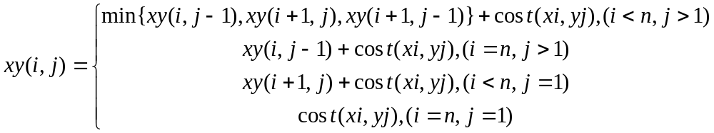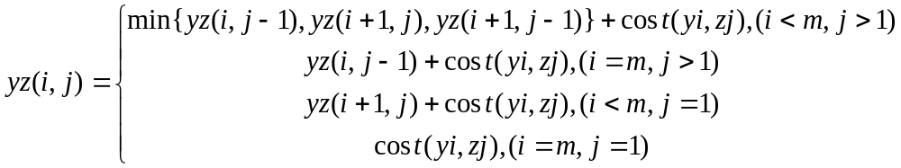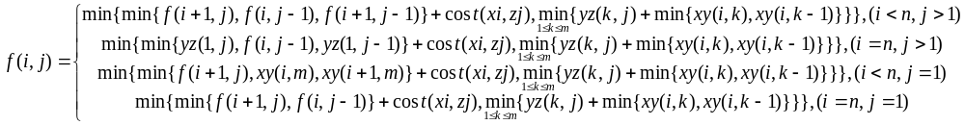
f（1，k）即为所求。

数据结构：

用三个100*100的数组f、xy、yz分别存储子问题1、2、3的解。

时空分析：

求xy、yz为二重循环，求f为三重循环，总的时间复杂度、空间复杂度均为O（n*m*k）。

源程序：

1682 Clans on the Three Gorges.cpp

